AHFA DMS How to Create Partnerships
“USER GUIDE”

Step 1:

- New User? Register Here will direct the user to the initial registration screen.
- New users must begin the registration process using the link below:
- https://multifamily.ahfa.com/AuthorityOnline/Default.aspx
- Go to New User.
- Instructions for New User Registration are on the link below:
http://www.ahfa.com/multifamily/allocation_application_info/apply_for_funding.aspx.
- Under AHFA DMS Guides, click- Authority Online User Registration Guide.
- Returning users will log on to DMS using the following link:
- https://multifamily.ahfa.com/AuthorityOnline/Default.aspx
- Log on with your existing User Id and Password.
- Your Programs page will appear.
- Click on My Profile.

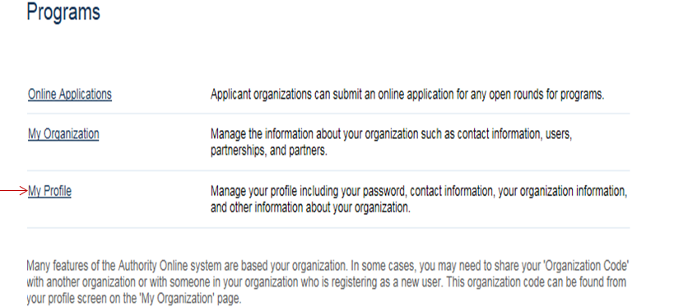

Step 2: Creating Partnerships
- After clicking “My Profile”, you can now access the Partnerships page.
- Click on Partnerships within the Organization section of the left navigation pane.

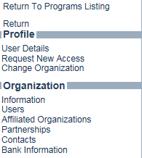

- On the Partnerships screen, a user has the opportunity to partner organizations within Authority Online. They can create a New Organization to partner if the Organization isn’t registered in Authority Online. The focus in this section will be the New Partnership section for this process.
- In the New partnership section, in this case we have the opportunity to designate how the AHFA organization is broken out. You’ll notice there are three sections within the New Partnerships section:

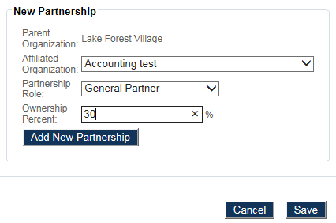

- Affiliated Organizations: This is a listing of all the affiliated organizations that have been linked to the AHFA organization. For organizations to appear in this drop down, they must have been linked to the organization using the Affiliated Organization process.

- Partnership Role: This will designate what partnership type for the organization selected in the Affiliated Organization drop down.

- Ownership Percent: The percentage the affiliated organization has in the parent organization

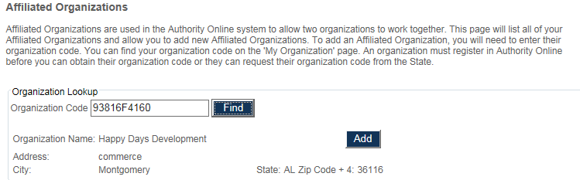

Step 3: From the dropdown boxes, choose Affiliated Organization.
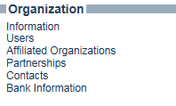
- Choose Partnership Role.
- Enter Ownership Percent.
- Click on Add New Partnership.
- Save.
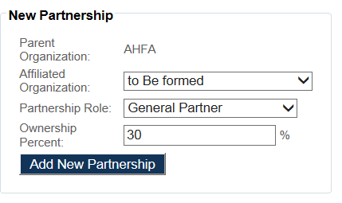

Step 4: After Adding Partnerships
- Now that a new Partnership has been added, you will now see the organization selected in the Partnerships section of the page.
- Implement this process for all of the partners you would like to create for your organization’s information and users permissions.

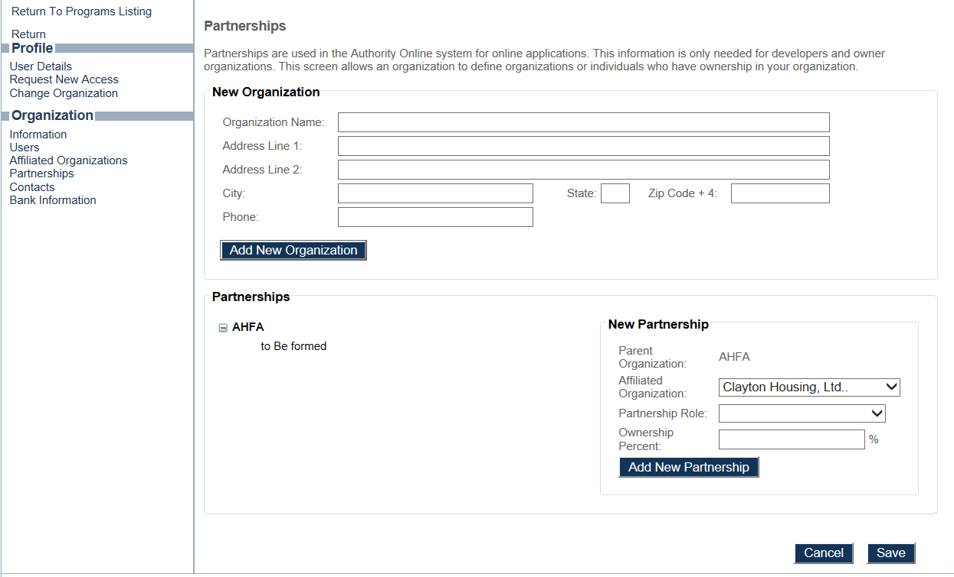
Step 5: Affiliating Existing Organizations
- If an Organization/Individual already exists in Authority DMS, you will need to Affiliate the Organization by using its Organization Code. This will allow the Organization/Individual to appear in the dropdown box (indicated below).
- Go to Affiliated Organization.
- Enter Organization Code.
- Click Find.
- Click Add.

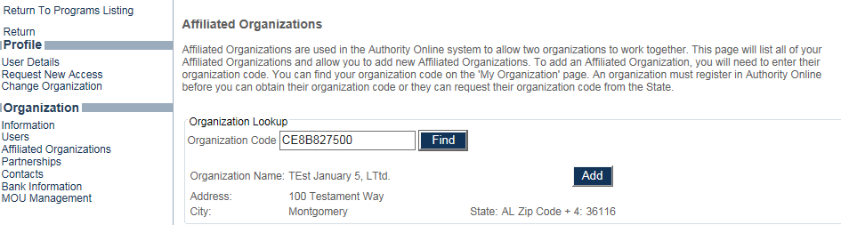

Step 6: Go back to Partnership to complete process
- NOTE: When adding a partnership to a structure, you must select that structure so that the Partnership is inserted accordingly. See examples below:

- Go back to Partnership
- Select Organization.
- From Partnership dropdown box, select the organization you are affiliating.
- Choose Role from the dropdown box.
- Add Ownership Percent.
- Add New Partnership.
- Don’t forget to Save after each Partnership has been added.

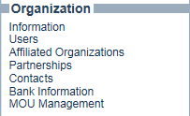

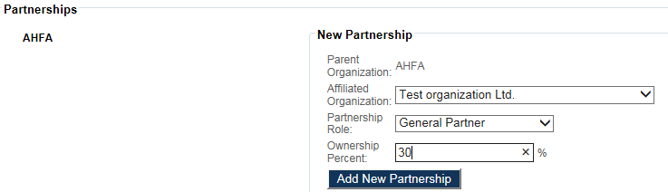
Select Organization here.
Choose role here

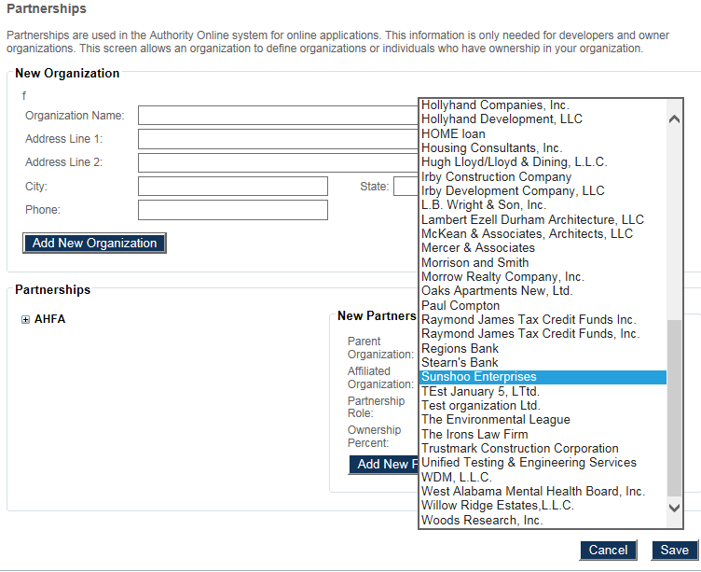
From dropdown box, select correct organization to affiliate.
Note: Adding (Test Organization) under AHFA.

Step 6.1 Creating your Organization’s hierarchy
- The screen below displays how this particular structure is formed. (i.e., AHFA is the Parent Organization Test Organization Ltd. owns Sunshoo Enterprises Sunshoo Enterprises owns Happy Days Development.
- Implement this process for all of the Partnerships you need to create for your organization’s information
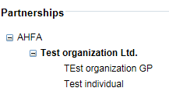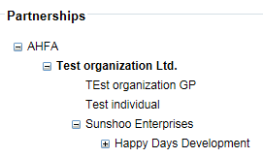
Note: New Partnership, Sunshoo Enterprises added under (Test Organization).
Note: New Partnership (Happy Days Development) added under Sunshoo Enterprises.

Note: If you need to remove a structure you may have added in error, you must click on that structure, (as indicated below) so that it is properly removed.
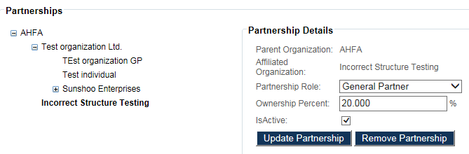

Step 7: Changing Organizations
- If you need to Change Organizations as you set up Partnership structures and you are in the application, go to “Return to Programs Listing”
- Go to My Profile
- Click Change Organization.
- Choose Organization you are changing.
- Click Set after choosing the organization.
- Update your Partnership structures.
- Return to Programs Listing to continue your application.

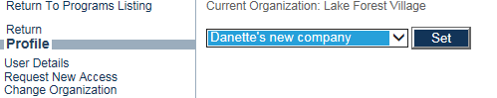
*Important Reminder: Don’t forget to “Change” Organization (Return to Programs Listing to access your application).

