Affiliated Organization Registration
“USER GUIDE”

Step 1: Users Login:
https://multifamily.ahfa.com/AuthorityOnline/Default.aspx
- New User? Register Here will direct the user to the initial registration screen.
- New users must begin the registration process using the link below:
- Go to New User.
- Instructions for New User Registration are on the link below:
http://www.ahfa.com/multifamily/allocation_application_info/apply_for_funding.aspx.
- Under AHFA DMS Guides, click- Authority Online User Registration Guide.
- Returning users will log on to DMS using the following link:
- https://multifamily.ahfa.com/AuthorityOnline/Default.aspx
- Log on with your existing User Id and Password.

Step 2: Accessing Affiliate Organization

- Once you are logged on, the screen below will appear.
- You may click My Profile or My Organization to access Affiliate Organizations.
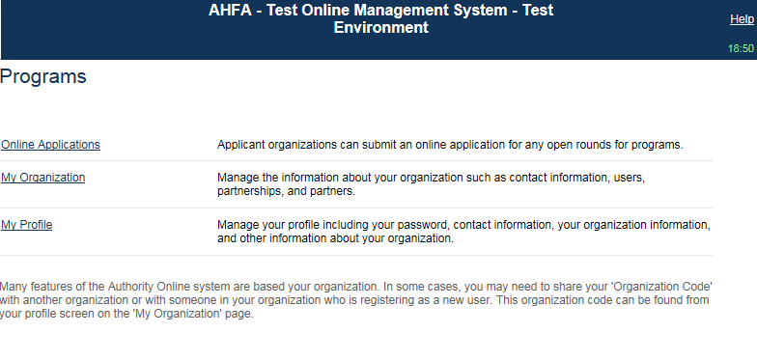
- Select Affiliate Organizations
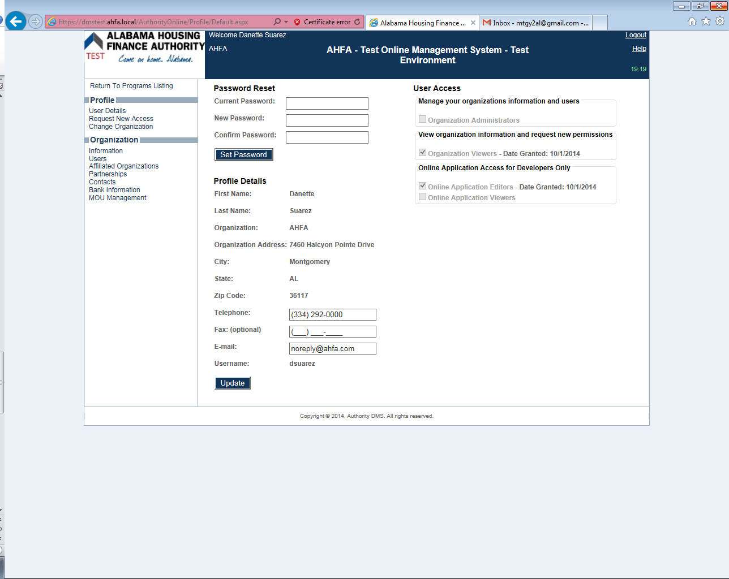

Step 3: The Organization Code from the “Entity” you are are trying to Affiliate, must be provided.
- Enter the Organization in the box below.
- Select Find.
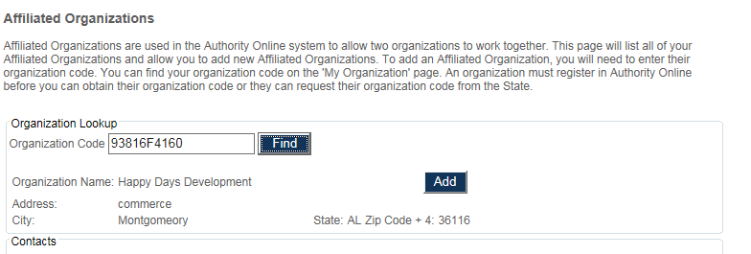

If the Organization is currently registered, the organization’s information will appear in addition to the option to (add) the Organization.

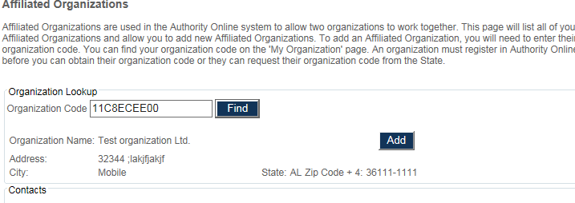

Step 4: Adding Organizations
- All of the contacts affiliated with that Organization will show as well.
- The Organization will appear in the list once you select Add. See the box below.
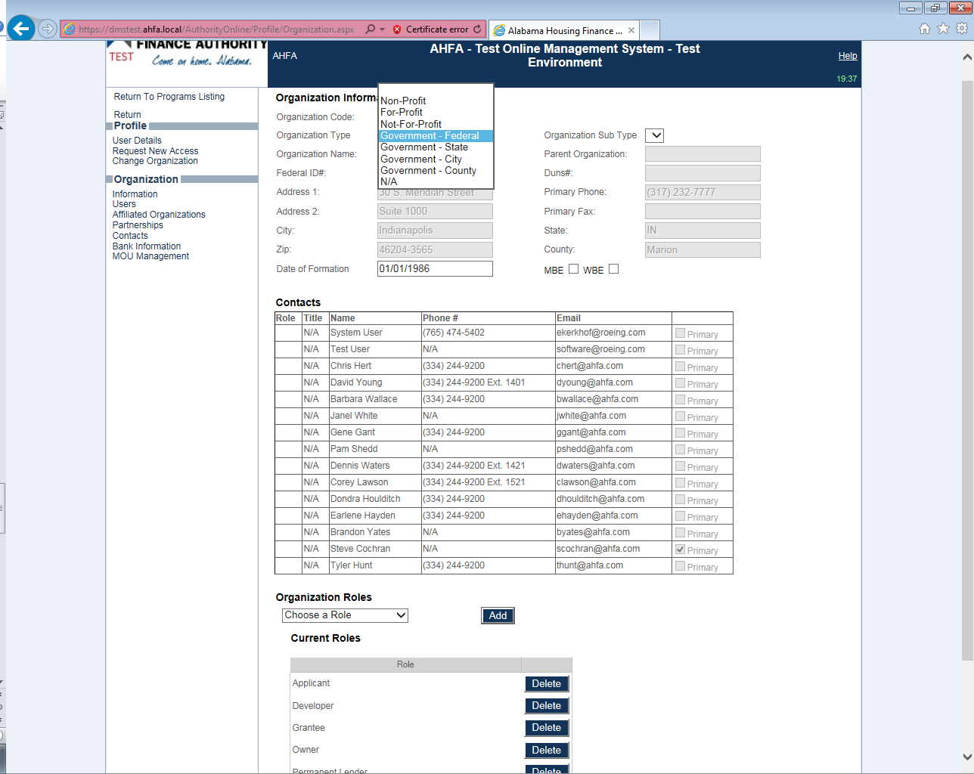

- Repeat for each Organization Code as needed.
- Make sure all of the organizations necessary; appear under the Affiliated Organization Header.
- Please note, the option to Remove the Organization materializes once you add it (see box below).

